Week 4 report of Internship

Ammar Akram
Name

DVS-8041
ID

Machine Learning
Domain

Ofiice
Devsphere

28/09/2026
Date

DEVSPHERE AI & ML INTERNSHIP

WEEK 4 — CLASSIFICATION MODELS
Breast Cancer Classification using Logistic Regression

1. Project Overview:
This project was completed as part of the DevSphere AI & ML Internship Week 4 task. The objective was to implement a classification model, train it on a classification dataset, generate predictions, and evaluate the model using an accuracy score and confusion matrix.

2. Dataset:
The Breast Cancer Wisconsin dataset available through Scikit-learn was used for this project.

Dataset Detail | Value
Total Samples | 569
Total Features | 30
Classes | Malignant, Benign
Training Samples | 455
Testing Samples | 114

3. Data Preparation:
The dataset was divided into training and testing sets using an 80/20 split.
The following settings were used:
- Test size: 20%
- Random state: 42
- Stratified train/test split
- Feature scaling using StandardScaler
- Feature scaling was applied before training the classification model to standardize the input features.

4. Classification Model:
The classification algorithm used for this task was Logistic Regression.
The model was trained using the scaled training dataset and then used to predict the class of each sample in the testing dataset.
The two classification classes were:
- Malignant
- Benign

5. Predictions:
After training, the model successfully generated predictions for the 114 testing samples.

Sample predictions:
[0, 1, 0, 1, 0, 1, 1, 0, 0, 0]

6. Model Evaluation:
The trained model achieved an accuracy of:
98.25%
Evaluation Metric | Result
Model | Logistic Regression
Test Samples | 114
Accuracy | 98.25%

The classification report also showed strong precision, recall, and F1-score for both classification classes.

7. Confusion Matrix:
The confusion matrix was generated to compare the actual classifications with the predictions made by the model.
Confusion Matrix
[[41, 1],
[1, 71]]
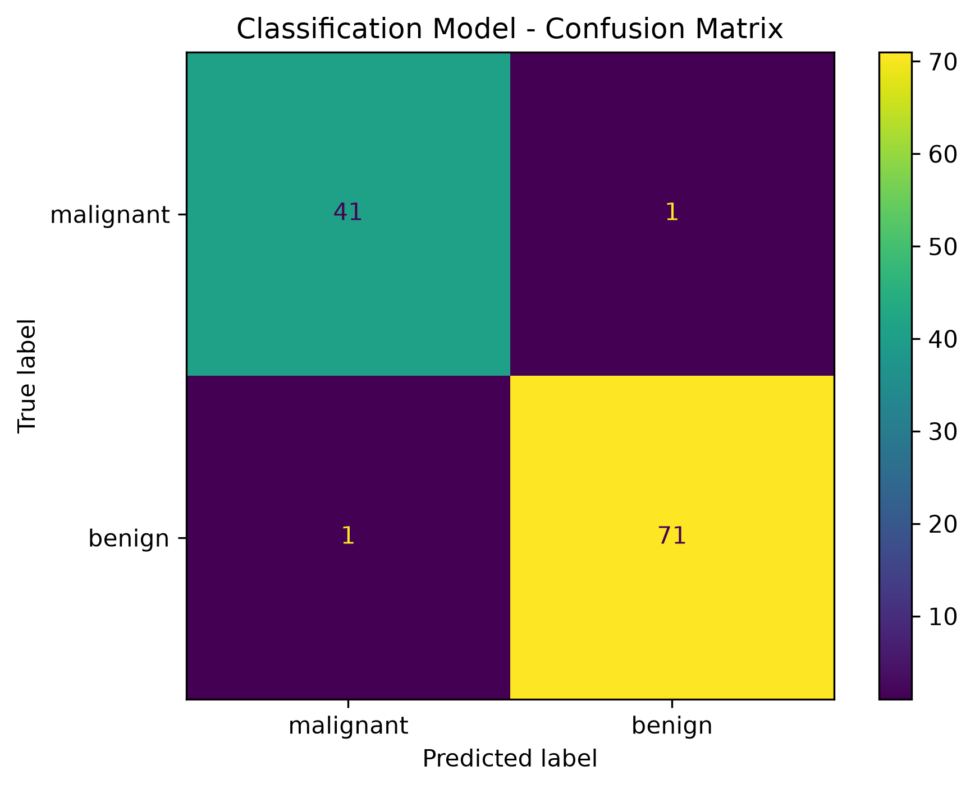
8. Model Saving:
The trained classification model was saved as:
classification_model.pkl
The saved file contains the trained Logistic Regression model, feature scaler, feature names, and target class names.

9. Technologies Used
- Python
- Pandas
- Scikit-learn
- Matplotlib
- Joblib
- Jupyter Notebook

11. Conclusion
The Week 4 classification task was successfully completed. A Logistic Regression model was trained using the Breast Cancer Wisconsin dataset and achieved 98.25% accuracy on the test dataset.

